COURSE SYLLABUS

2 2
0 0
1 2
9 1

Mathematics Analysis and Approaches HL

DIPLOMA PROGRAMME

Course Overview

Mathematics analysis and approaches course recognizes the need for analytical expertise in a world where innovation is increasingly dependent on a deep understanding of mathematics. This course includes topics that are both traditionally part of a pre-university mathematics course (for example, functions, trigonometry, calculus) as well as topics that are amenable to investigation, conjecture and proof, for instance the study of sequences and series and proof by induction.
The course allows the use of technology, as fluency in relevant mathematical software and hand-held technology is important regardless of choice of course.

This course also recognizes the increasing role that mathematics and technology play in a diverse range of fields in a data-rich world. As such, it emphasizes the meaning of mathematics in context by focusing on topics that are often used as applications or in mathematical modelling.
The course makes extensive use of technology to allow students to explore and construct mathematical models. Mathematics: applications and interpretation will develop mathematical thinking, often in the context of a practical problem and using technology to justify conjectures.

An important aspect of the mathematics courses is that students develop the ability to systematically analyse situations and can recognize the impact that mathematics can have on the world around them. An awareness of how mathematics can be used to represent the truth enables students to reflect critically on the information that societies are given or generate, and how this influences the allocation of resources or the choices that people make.

Learning Outcomes

The aims of AA HL mathematics course is to enable students to:

- develop a curiosity and enjoyment of mathematics, and appreciate its elegance and power
- develop an understanding of the concepts, principles and nature of mathematics
- communicate mathematics clearly, concisely and confidently in a variety of contexts
- develop logical and creative thinking, and patience and persistence in problem solving to instil confidence in using mathematics
- employ and refine their powers of abstraction and generalization
- take action to apply and transfer skills to alternative situations, to other areas of knowledge and to future developments in their local and global communities
- appreciate how developments in technology and mathematics influence each other
- appreciate the moral, social and ethical questions arising from the work of mathematicians and the applications of mathematics
- appreciate the universality of mathematics and its multicultural, international and historical perspectives
- appreciate the contribution of mathematics to other disciplines, and as a particular “area of knowledge” in the TOK course
- develop the ability to reflect critically upon their own work and the work of others
- independently and collaboratively extend their understanding of mathematics.

Unit Overviews

Topic 1 –Number and Algebra
Approximate Length: 39 hours

Unit description: The aim of the AAHL content in the number and algebra topic is to extend and build upon the aims, concepts and skills from the SL content. It introduces students to some important techniques for expansion, simplification and solution of equations. Complex numbers are introduced and students will extend their knowledge of formal proof to proof by mathematical induction, proof by contradiction and proof by counterexample.

Key concepts: Generalization, patterns, representation, modelling, patterns, quantity, equivalence, validity, systems,
exponents, logarithms, counting principles, complex numbers.
Learning outcomes:
- Arithmentic and geometric sequences and series
- Calculate nth term and sum of series
- Convert between exponents and logs
- Finding approximations
- Modelling real-life situations
- Partial fractions
- Prove by induction
- Prove by contradiction
- Solving systems of linear equations
- Represent complex numbers on an Argand diagram

Topic 2 – Functions
Approximate Length: 32 hours
Unit description: The aim of the AAHL content in the functions topic is to introduce students to useful techniques for finding and using roots of polynomials, graphing and interpreting rational functions, additional ways to classify functions, solving inequations and solving equations involving modulus notation. AAHL students may be required to use technology to solve equations where there is no appropriate analytic approach.

Key concepts: Relationship, representation, space, quantity, systems, patterns

Learning outcomes:
- Finding roots of polynomial functions
- Graph rational functions
- Solving inequalities graphically and analytically
- Investigate graph transformations
- Finding solutions of modulus equations and inequalities

Topic 3 – Geometry and trigonometry
Approximate Length: 51 hours

Unit Description: Geometry and trigonometry allows students to quantify the physical world, enhancing spatial awareness in two and three dimensions.
The aim of the AAHL content in the geometry and trigonometry topic is to extend and build upon the aims, concepts and skills from the SL content. It further explores the circular functions, introduces some important trigonometric identities, and introduces vectors in two and three dimensions. This will facilitate problem-solving involving points, lines and planes.

Key concepts: Generalizations, space, quantity, modelling, radian measure, unit circle, trigonometric identities, sine and cosine rules

Learning outcomes:
- Distance between two points
- Volume and surface of three-dimensioanl solids
- Reciprocal trigonometric ratios
- Use trigonometric identities to solve equations
- Derivation of double angle identities from compound angle identities
- Use sine and cosine rules to calculate angles and lengths
- Cocept of a vector
- Operations with vectors, angle between two vectors, between a line and a plane, or between two planes.

Topic 4 – Statistics and probability
Approximate Length: 33 hours

Unit Description: The aim of the AHL content in the statistics and probability topic is to introduce students in further conditional probability theory in the form of Bayes Theorem and properties of discrete and continuous random variables are further explored.
Key concepts: Organizing, representing, analyzing and interpreting data, properties of probability functions, comparing variations, correlations

Learning outcomes:
- Use of Bayes’ theorem
- Variance of a discrete random variable
- Probability density functions
- Mean, variance and standard deviation of discrete and continuous random variable

Topic 5 – Calculus
Approximate Length: 55 hours

Unit Description: The aim of the AAHL content in the calculus topic is to introduce students to the concepts and techniques of differential and integral calculus and their applications.
Throughout this topic students should be given the opportunity to use technology such as graphing packages and graphing calculators to develop and apply their knowledge of calculus.

Key concepts: Rate of change, differentiation, continuity, integration, kinematics, optimisation

Learning outcomes:
- Limit concept (convergence and divergence)
- Higher derivatives
- Evaluation of limits (l’Hopital rule, Maclaurin series)
- Implicit differentiation
- Optimisation problems
- Integrate by substitution and by parts
- Area of the region enclosed by a curve and y-axis
- Volumes of revolution
- Differential equations

Assessment
Assessment is an integral part of teaching and learning. There are two types of assessment identified by the IB.
Formative assessment informs both teaching and learning. It is concerned with providing accurate and helpful feedback to students and teachers on the kind of learning taking place and the nature of students’ strengths and weaknesses in order to help develop students’ understanding and capabilities.
Summative assessment gives an overview of previous learning and is concerned with measuring student achievement.
All summative assessments will be graded on the 1-7 IB scale. All reports will reflect the IB 1-7 grading scale and will be based the best-fit approach to assessment.

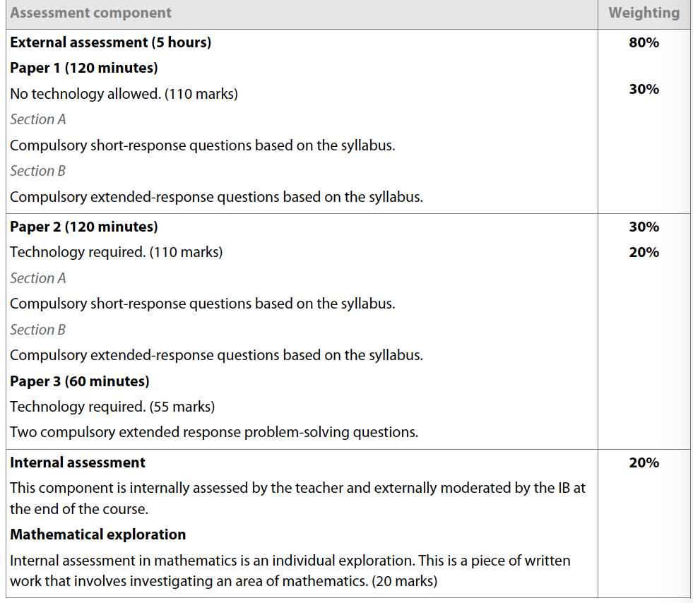

Grade Boundaries

Paper 1 |  | Paper 2 |  | Paper 3 |  | Internal | Assessment
Grade | Mark Range | Grade | Mark Range | Grade | Mark Range | Grade | Mark Range
1 | 0 – 16 | 1 | 0 – 18 | 1 | 0 - 7 | 1 | 0 -2
2 | 17 – 33 | 2 | 19 – 36 | 2 | 8 – 14 | 2 | 3 -5
3 | 34 – 44 | 3 | 37 – 49 | 3 | 15 – 23 | 3 | 6 -8
4 | 45 – 58 | 4 | 50 – 63 | 4 | 24 – 28 | 4 | 9 -11
5 | 59 – 73 | 5 | 64 – 77 | 5 | 29 – 34 | 5 | 12 -14
6 | 74 – 87 | 6 | 78 – 91 | 6 | 35 – 43 | 6 | 15 -16
7 | 88 – 110 | 7 | 92 – 110 | 7 | 44 – 55 | 7 | 17 -20

Course Grade Descriptors

While we will look carefully at the grades students have achieved on the various assessments, ultimately, quarterly grades as well as predicted grades will be based on the following grade descriptors.

Grade 7
Demonstrates a thorough knowledge and comprehensive understanding of the syllabus; successfully constructs and applies mathematical arguments at a sophisticated level in a wide variety of contexts; successfully uses problem-solving techniques in challenging situations; recognizes patterns and structures, makes generalizations and justifies conclusions; understands and explains the significance and validity of results, and draws full and relevant conclusions; communicates mathematics in a clear, effective and concise manner, using correct techniques, notation and terminology; demonstrates the ability to integrate knowledge, understanding and skills from different areas of the course; uses technology correctly in challenging situations—makes efficient use of calculator’s functionality when required.

Grade 6
Demonstrates a broad knowledge and comprehensive understanding of the syllabus; successfully constructs and applies mathematical arguments in a variety of contexts; uses problem-solving techniques in challenging situations; recognizes patterns and structures, and makes some generalizations; understands and explains the significance and validity of results, and draws relevant conclusions; communicates mathematics in a clear and effective manner, using correct techniques, notation and terminology; demonstrates some ability to integrate knowledge, understanding and skills from different areas of the course; uses technology correctly in routine situations—makes efficient use of calculator’s functionality when required.

Grade 5
Demonstrates a broad knowledge and good understanding of the syllabus; applies mathematical arguments in performing routine tasks; successfully uses problem-solving techniques in routine situations; successfully carries out mathematical processes in a variety of contexts, and recognizes patterns and structures; understands the significance of results and draws some conclusions; communicates mathematics effectively, using appropriate techniques, notation and terminology; demonstrates an awareness of the links between different areas of the course; makes use of calculator’s functionality when required—may occasionally be inefficient.

Grade 4
Demonstrates a satisfactory knowledge of the syllabus; applies mathematical arguments in performing some routine tasks; uses problem-solving techniques in routine situations; successfully carries out mathematical processes in straightforward contexts; shows some ability to recognize patterns and structures; has limited understanding of the significance of results and attempts to draw some conclusions; communicates mathematics adequately, using some appropriate techniques, notation and terminology; makes some use of calculator’s functionality, but perhaps not always when required—may be inefficient at times.

Grade 3
Demonstrates partial knowledge of the syllabus and limited understanding of mathematical arguments in performing some routine tasks; attempts to carry out mathematical processes in straightforward contexts; makes an attempt to use problem-solving techniques in routine situations; communicates some mathematics, using some appropriate techniques, notation or terminology; occasionally uses calculator’s functionality, but often inefficiently; does not always use it when required and may use an inefficient analytic approach.

Grade 2
Demonstrates limited knowledge of the syllabus; attempts to carry out mathematical processes at a basic level; communicates some mathematics, but often uses inappropriate techniques, notation or terminology; unable to use calculator correctly when required—questions exclusively requiring the use of the GDC are generally not attempted.

Grade 1
Demonstrates minimal knowledge of the syllabus; demonstrates little or no ability to use mathematical processes, even when attempting routine tasks; communicates only minimal mathematics and consistently uses inappropriate techniques, notation or terminology; is unable to make effective use of technology.

Students Responsibilities

Academic Honesty

Protocol For In-School Malpractice
The following steps will be followed in cases of malpractice:
- Teachers will advise students of suspicion of misconduct
- A record of the incident will be forwarded to the Diploma Programme Coordinator
- The Diploma Programme Coordinator will discuss the incident with the teacher
- The Diploma Programme Coordinator will interview the student involved
- The Diploma Programme Coordinator will forward his or her assessment of the incident to the Secondary School Assistant Principal
- The Secondary School Assistant Principal will assess the infraction and impose the corresponding consequence, if necessary.

Malpractice on Assessments to be Submitted to the IB
According to the Academic Honesty (2009) document, in cases of malpractice on assessments or exam that are intended for submission to the IB, the following protocol has been put in place.

Once a candidate has submitted his or her work to a teacher (or the coordinator) for external or internal assessment together with the coversheet signed (or authenticated electronically) to the effect that it is the final version of the work, neither the work nor the coversheet can be retracted by the candidate. If the candidate is subsequently suspected of plagiarism or collusion, it is no defense to claim that the incorrect version of the work was submitted for assessment.

After a candidate has signed and dated the coversheet (or authenticated electronically)to the effect that his or her work is authentic and constitutes the final version of that work, the candidate’s teacher (or supervisor in the case of an extended essay) must also sign and date the coversheet to the effect that to the best of his or her knowledge it is the authentic work of the candidate. Any suspicion of malpractice that arises after the candidate has signed the coversheet must be reported to the coordinator help desk at IB Cardiff for investigation. However, if there is no tangible evidence of malpractice (such as the source of plagiarism) the candidate must be given the benefit of any doubt and the coversheet must be signed by the teacher/supervisor. It is not acceptable for the teacher to:
- delete the declaration and then sign the coversheet
- submit the work for assessment without his or her signature
- sign the declaration and then write comments on the work or coversheet that raise doubts about the work’s authenticity.
- In the above circumstances the IB will not accept the work for assessment (or moderation) unless confirmation is received from the school that the candidate’s work is authentic.

If a teacher is unwilling to sign a coversheet owing to a suspicion of malpractice, the matter must be resolved within the school. The coordinator has the option of informing the coordinator help desk that the work will not be submitted on behalf of the candidate (resulting in no grade being awarded for the subject or diploma requirement).

Malpractice in Testing Situations:
Students may not:
- take unauthorized material into an examination room (see below)
- leave and/or access unauthorized material in a bathroom/restroom that may be visited during a test
- pass on information to another student about the content of an examination, this includes facilitating the exchange information between other students in any way
- steal examination papers
- using an unauthorized calculator during an examination

Students must not have unauthorized material (for example, own rough paper, notes, a mobile/cell phone or an electronic device other than a permitted calculator) in their possession during a testing situation. “In their possession” may be taken to mean on the person of the student, in the student’s immediate proximity (such as on the floor or desk) or placed somewhere (such as a bathroom/restroom) for access during the test. It is very important to note that guilt will be confirmed by the school administration regardless of whether this material is used, was or was not intended for use or contains information relevant or potentially relevant to the test. The actual possession of unauthorized material constitutes malpractice; the school administration is not required to establish whether the student used or intended to use the material. No leniency is shown to a candidate who claims that they were unaware the material was in their possession.

Late Assessment Policy

Late Assessments:
Should a student not complete a summative assessment on time (this includes summative drafts) teachers will:
● Speak with the student to find out why the assessment has not been submitted.
● An email home will be sent to parents detailing the missed assessment and the student will be asked to stay in school until it is completed.
● If the assessment is pending, once received, they log the infraction in the “reward and conduct” tab in iSAMS regarding the tardiness of the assessment.
o Note: in the case of pending assessments, any arrangements with students will not exceed 24 hours.
● If a student does not attend after school to work on the assessment, the teacher will confer with the student and, if necessary, refer the incident to the Grade Leader. The Grade Leader will discuss the situation with the student to see if support is required or consequences need to be imposed. The Grade Leader will subsequently record the incident in iSAMS. Further incidents of truancy will be escalated to the Secondary School Administration.
● If there is a second incident of a late submission of an assessment, the teacher will report it in an email to the Grade Leader who may contact parents for a meeting where you may be included. The Grade Leader will record their actions in iSAMS.
● Further incidents of late assessments will be reported to Grade Leaders who will forward the incident(s) to the Secondary School administration who, if warranted, will initiate an in-school suspension where students will complete the assessment until it is completed to standard. A record of the suspension will be recorded in iSAMS and prompt a communication with parents.
● Any subsequent incidents of late assessments will necessitate a parent meeting with a member of the Secondary School Administration to determine the best way forward.

Tests Absenteeism
● In cases where students are not in school on a test day, a communication from parents will be required.
● The student will need to present their teacher with a doctor’s note upon their return to class if the test is to be administred with no consequence.
● Should an authorized absence not be received, the student may not be permitted to write the test and an “NA” representing an “incomplete” will appear on the next quarterly report.
● If this incident reoccurs, the issue will be escalated to the Head of Senior School and will receive a ‘O’.
● Aside from school activities, all test absences will be recorded in iSAMS by the teacher with a note in the “record description” whether the test absence was authorized or not. The Grade Level Leader may follow-up with the student, if necessary.

Teacher Assessment Commitments

All teachers will:
● Provide feedback on all formative assessments within one calendar week of receipt.
● Post on Managebac (shaded in purple) any formative assessment (including homework) no later than 5:00PM the day it is assigned. If the formative assessment is not posted by this time there is no expectation that the assessment will be completed for the next day.
● Discuss with students prior to posting summative assessments and provide at least one calendar week lead time for students to prepare. Summative assessments will be posted on Managebac at least one week in advance of the due date (shaded in blue).
● Work collaboratively with their teacher colleagues and coordinator to work toward the goal of students having no more than two (2) summative assessments on a given day.
● Return summative assessments to students with feedback no later than three calendar weeks after the due date.
● Update Managebac immediately upon completion of marking/feedback.
● Communicate, in a timely fashion, with colleagues and administration about students who are turning in late formative and summative tasks in order to implement late assessment procedures, as outlined in the Assessment Policy. Late assessment procedures are outlined below.
● Communicate with parents when assignments/assessments are not turned in on the due date and clearly articulate the next steps for the student.

Appendix

Command terms with definitions
Students should be familiar with the following key terms and phrases used in examination questions, which are to be understood as described below. Although these terms will be used in examination questions, other terms may be used to direct students to present an argument in a specific way.
Calculate | Obtain a numerical answer showing the relevant stages in the working.
Comment | Give a judgment based on a given statement or result of a calculation.
Compare | Give an account of the similarities between two (or more) items or situations, referring to both (all) of them throughout.
Compare and contrast | Give an account of the similarities and differences between two (or more) items or situations, referring to both (all) of them throughout.
Construct | Display information in a diagrammatic or logical form.
Contrast | Give an account of the differences between two (or more) items or situations, referring to both (all) of them throughout.
Deduce | Reach a conclusion from the information given.
Demonstrate | Make clear by reasoning or evidence, illustrating with examples or practical application.
Describe | Give a detailed account.
Determine | Obtain the only possible answer.
Differentiate | Obtain the derivative of a function.
Distinguish | Make clear the differences between two or more concepts or items.
Draw | Represent by means of a labelled, accurate diagram or graph, using a pencil. A ruler (straight edge) should be used for straight lines. Diagrams should be drawn to scale. Graphs should have points correctly plotted (if appropriate) and joined in a straight line or smooth curve.
Estimate | Obtain an approximate value.
Explain | Give a detailed account, including reasons or causes.
Find | Obtain an answer, showing relevant stages in the working.
Hence | Use the preceding work to obtain the required result.
Hence or otherwise | It is suggested that the preceding work is used, but other methods could also receive credit.
Identify | Provide an answer from a number of possibilities.
Integrate | Obtain the integral of a function.
Interpret | Use knowledge and understanding to recognize trends and draw conclusions from given information.
Investigate | Observe, study, or make a detailed and systematic examination, in order to establish facts and reach new conclusions.
Justify | Give valid reasons or evidence to support an answer or conclusion.
Label | Add labels to a diagram.
List | Give a sequence of brief answers with no explanation.
Plot | Mark the position of points on a diagram.
Predict | Give an expected result.
Prove | Use a sequence of logical steps to obtain the required result in a formal way.
Show | Give the steps in a calculation or derivation.
Show that | Obtain the required result (possibly using information given) without the formality of proof. “Show that” questions do not generally require the use of a calculator.
Sketch | Represent by means of a diagram or graph (labelled as appropriate). The sketch should give a general idea of the required shape or relationship, and should include relevant features.
Solve | Obtain the answer(s) using algebraic and/or numerical and/or graphical methods.
State | Give a specific name, value or other brief answer without explanation or calculation.
Suggest | Propose a solution, hypothesis or other possible answer.
Verify | Provide evidence that validates the result.
Write down | Obtain the answer(s), usually by extracting information. Little or no calculation is required. Working does not need to be shown.

