1 July, 2018
Dear GWA Families,

We hope this message finds you well and your family is enjoying the summer vacation before school starts on September 2nd for new students. We are continuing the one-to-one iPad implementation for Grade 4-9 students at the beginning of the 2018-2019 school year. The school is providing a list of applications that are the student’s responsibility to download. These apps are listed below. Please note these apps are different for each grade level. Please do not download the apps to your student’s iPad yet. Before these apps are downloaded to your child’s iPad, we will need to register the iPad within our Multiple Device Management (MDM) system. This MDM system allows the school to control which applications are used and when during the school day. The MDM is designed to ensure safe and acceptable use of the device as well as maximum instructional and learning benefits. Following the registration process, students can download the apps listed below.

Additionally, we would like to remind our families of the Digital Citizenship & Acceptable Use Policy that can be found in our Family-Student Handbook at this link. Please note that students need to bring their iPad to school each day, fully charged and ready to go.

Apps for Grades 6-9: Below is a schematic with pictures of the applications. On the following page is a list of the apps and the purpose they serve.

We very much look forward to ensuring that the implementation of iPads enhances your child’s learning experience at GWA. Thank you for your continued support.

Sincerely,
Stuart Walker
Head of School & CEO

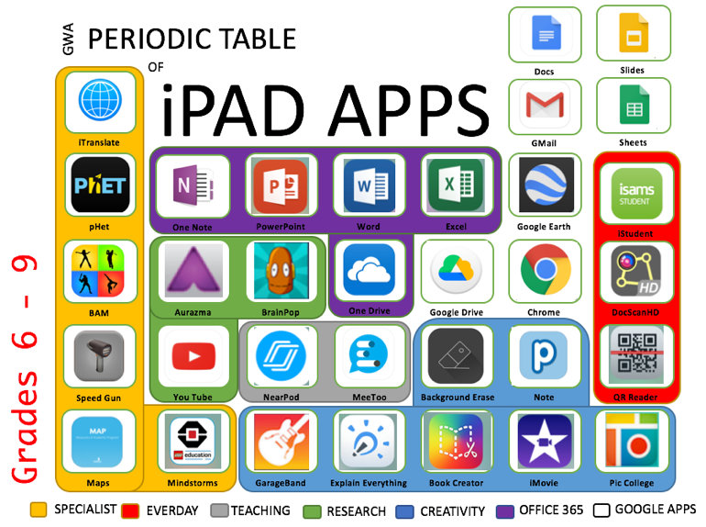

Grades
6-8 iPad Apps for Semester One Academic Year 2018 – 2019
Name of App | Cost (in AED) | Explanation
iStudent APP | Free | Student reports timetables, class attendance data. (Students username  and password provided by school)
Book Creator | AED 17.99 | Allows students to create documents that include images, videos,  speech, weblinks for formative and summative assessments.
Explain Everything | AED 29.99 | Allows students to create videos and classroom projects for formative  and summative assessments through Interactive screen casting.
IMOVIE | Free | Allow for creation of movies, short features and other video presentations.
OFFICE 365 | Free | Full Office 365 suite apps needed: Word, PowerPoint, Excel, One  Note.  Daily use for report writing, data collection, presentation software.  (This will be linked to students office 365 accounts provided by the school)
pHet Simulations | AED 3.69 | Allows for students to complete Science Lab simulations
Google suite of apps | Free | The following Apps are needed: Drive, Docs, Slides, Sheets, Earth,  Chrome, Gmail and Youtube.  Daily use for report writing, data collection, presentation software.  Cloud storage. (This will be linked to students GAFE accounts provided by the school)
BAM Video Delay | AED 6.99 | To video and analyze movement within lessons.
Speed Gun | FREE | Use for measuring speed of students and ball speed within PE.
Garageband | free | For composing music also integrates with iMovie
Aurasma | Free | Augmented Reality allows students to bring posters / images to life.
Meetoo | Free | Interactive Quizzes, Q&A (Allowing teachers to assess students’  knowledge and understanding)
Nearpod | Free | Delivery of Lesson Content by teachers.
NEWA Map | Free | Software allowing students to Complete MAP Testing
Popplet | AED 17.99 | Allows students to capture and organize ideas
PicCollege | Free | Allowing for multiple photos to be collaged together.
BrainPop | Free | Researching tool allowing students to understand key terms and topics  being thought in a wide range of subjects (Username and Password Provided by school)
Background  Eraser | Free | Allows students to make background of images transparent.
DocscanHDPro | Free | DocScan HD lets you instantly scan multi-pages document and also  whiteboards, receipts, business cards, posters, coupons, books etc.
QR reader for iPad | Free | Scans QR, Barcodes, Documents and puzzles
Lego Mindstorm | Free | Programming and coding of robotics.
Read&write | Free | Allowing students to have support with reading and writing. School  will provide license code
Swift Playgrounds | Free | Swift Playgrounds requires no coding knowledge, so it’s perfect for students just starting out, from twelve to one-hundred-and-twelve. The whole time you are learning Swift, a powerful programming language created by Apple and used by professionals to build many of today’s most popular apps.
Notability | AED 36.99 | Students, teachers, and business professionals use Notability daily to take notes, sketch ideas, annotate PDFs, mark-up photos, record lectures, provide audio feedback and more.

We very much look forward to ensuring that the implementation of iPads enhances your child’s learning experience at GWA. Thank you for your continued support.

Sincerely,

Stuart Walker
Head of School & CEO

